**NUnits handsOn**

***Exercise:NUnit Test for Calculator Addition***

**1)Code**

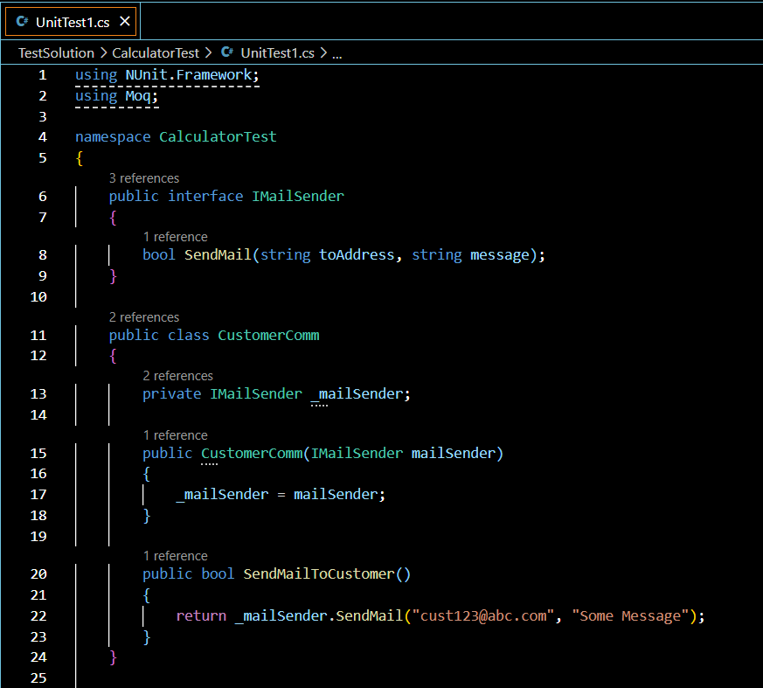

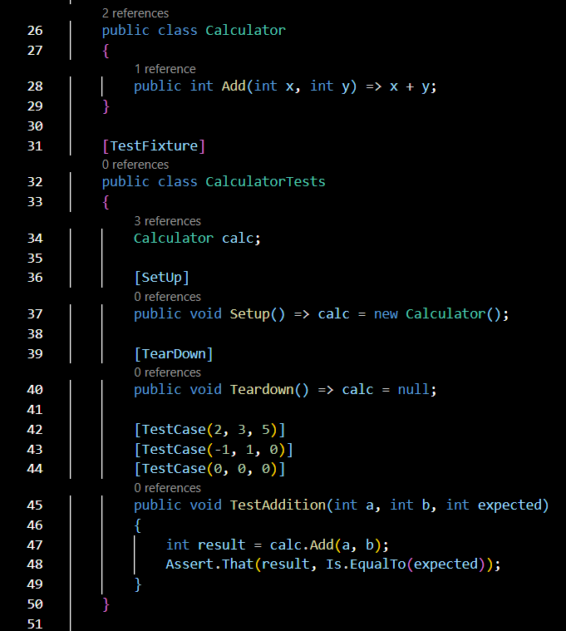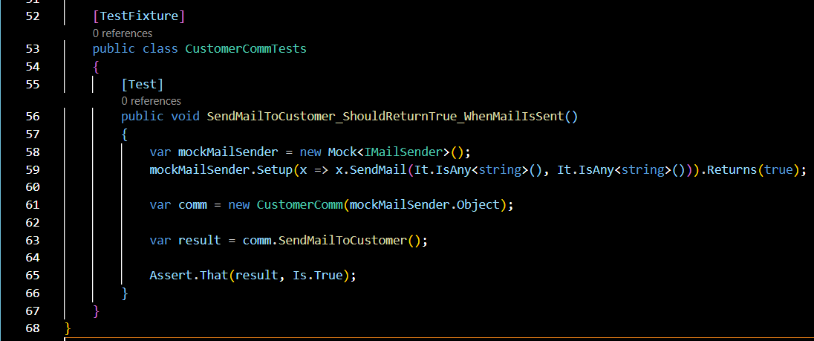

**2)Output**

